Edge Detection

Che-Ming Hu
E-mail: truexray@hotmail.com
Graduate Institute of Communication Engineering
National Taiwan University, Taipei, Taiwan, ROC
Abstract
Edges are boundaries between different textures. Edge also can be defined as discontinuities in image intensity from one pixel to another.. The edges for an image are always the important characteristics that offer an indication for a higher frequency. Detection of edges for an image may help for image segmentation ,data compression, and also help for well matching, such as image reconstruction and so on.

There are many methods to make edge detection. The most common method for edge detection is to calculate the differentiation of an image. The first-order derivatives in an image are computed using the gradient, and the second-order derivatives are obtained using the Laplacian. Another method for edge detection uses Hilbert Transform. And we have proposed a new method called short response Hilbert transform (SRHLT) that combines the differentiation method and the Hilbert transform method.

However, SRHLT improved the differentiation method and HLT, it still can not fulfill our request. We can view SRHLT as the medium between the differentiation operation and the Hilbert transform (HLT) for edge detection. Now, we will introduce improved harris’ algorithm and new corner detection algorithm. A more accurate algorithm for corner and edge detections that is the improved form of the well-known Harris’ algorithm is introduced. First, instead of approximating |L[m+x, n+y]–L[m, n]|2 just in terms of x2, xy, and y2, we will approximate |L[m+x, n+y]–L[m, n]|(L[m+x, n+y]–L[m, n]) by the linear combination of x2, xy, y2, x, y, and 1. There are 6 basis different from 3 basis. We can observe the sign of variation with this modifiction. It can avoid misjudging the pixel at the wrong location and is also helpful for increasing the robustness to noise. Moreover, we also use orthogonal polynomial expansion and table looking up and define the cornity as the “integration” of the quadratic function to further improve the performance. From simulations, our algorithm is effective both for corner detection and edge detection.

FIG 0.1 - Step edges. (a) The change in level occurs exactly at pixel 10. (b) The same level change as before, but over 4 pixels centered at pixel 10. This is a ramp edge. (c) Same level change but over 10 pixels, centered at 10. (d) A smaller change over 10 pixels. The insert shows the way the image would appear, and the dotted line shows where the image was sliced to give the illustrated cross-section.

FIG 0.2 - The effect of sampling on a step edge. (a) An ideal step edge. (b) Three dimensional view of the step edge. (c) Step edge sampled at the center of a pixel, instead of on a margin. (d) The result, in threedimensions, has the appearance of a staircase.

Introduction

- Fist-Order Derivative Edge Detection:
An important quantity in edge detection is the magnitude of this vector, denoted ∇f, Where
Another important quantity is the direction of the gradient vector. That is,
Computation of the gradient of an image is based on obtaining the partial derivatives
of ∂f/∂x and ∂f/∂y at every pixel location. Let the 3×3 area shown in Fig. 1.1
represent the gray levels in a neighborhood of an image. One of the simplest ways to
implement a first-order partial derivative at point z5 is to use the following Roberts
cross-gradient operators:
and
These derivatives can be implemented for an entire image by using the masks shown in Fig. 1.2 with the procedure of convolution.
Another approach using masks of size 3×3 shown in Fig. 1.3 which is given by

and

a slight variation of these two equations uses a weight of 2 in the center coefficient:
A weight value of 2 is used to achieve some smoothing by giving more importance to the center point. Fig.1.4, called the Sobel operators, is used to implement these two equations.

z₁ | z₂ | z₃
z₄ | z₅ | z₆
z₇ | z₈ | z₉

Fig. 1.1 A 3×3 area of an image.

Fig. 1.2 The Roberts operators.

Fig. 1.3 The Prewitt operators.

Fig. 1.4 The Sobel operators.

- Second-Order Derivative Edge Detection

The Laplacian of a 2-D function f (x, y) is a second-order derivative defined as

There are two digital approximations to the Laplacian for a 3×3 region:

where the z’s are defined in Fig. 2.1. Masks for implementing these two equations are
shown in Fig. 2.1.

Fig. 2.1 Two kind of 3×3 Laplacian mask.

The Laplacian is usually combined with smoothing as a precursor to finding edges via zero-crossings. The 2-D Gaussian function

where σ is the standard deviation, blurs the image with the degree of blurring being determined by the value of σ. The Laplacian of h is

This function is commonly referred to as the Laplacian of Gaussian (LOG).
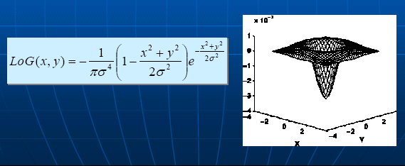
Fig. 2.2 3-dimension coordinate of Laplacian of Gaussian (LOG).

After calculating the two-dimensional second-order derivative of an image, we find the value of a point which is greater than a specified threshold and one of its neighbors is less than the negative of the threshold. The property of this point is called
zero-crossing and we can denote it as an edge point.

We note two additional properties of the second derivative around an edge: (1) It
produces two values for every edge in an image (an undesirable feature); and (2) an imaginary straight line joining the extreme positive and negative values of the second
derivative would cross zero near the midpoint of the edge. This zero-crossing property
of the second derivative is quite useful for locating the centers of thick edges.

Fig. 2.3 Using differentiation to detect (a) the sharp edges, (c) the step edges with
noise, and (e) the ramp edges. (b)(d)(e) are the results of differentiation of (a)(c)(e).

3. Hilbert Transform for Edge Detection

There is another method for edge detection that uses the Hilbert transform (HLT). The HLT is
and * means convolution. Alternatively,
where G( f ) = FT [g(x)] (FT means the Fourier transform), G_{H}( f ) = FT [g_{H} (x)], and
,
where the sign function is defined as

Fig. 3.1 Using HLTs to detect (a) the sharp edges, (c) the step edges with noise, and (e) the ramp edges. (b)(d)(e) are the results of the HLTs of (a)(c)(e)

4. Short Response Hilbert Transform for Edge Detection

Based on Canny’s criterion, we develop the short response Hilbert transform (SRHLT), which is the intermediate of the original HLT and the differentiation operation. For edge detection, the SRHLT can compromise the advantages of the HLT and differentiation. It can well distinguish the edges from the non-edge regions and at the same time are robust to noise. We also find that there are many ways to define the SRHLT. If the constraints which come from Canny’s criterion are satisfied, the resultant SRHLT will have good performance in edge detection.

The Definition of the SRHLT
We combine the HLT and differentiation to define the SRHLT. From the theorem of the Fourier Transform,
where
,
Therefore, from the scaling property of the FT:
,
we obtain
.

From, we can define the short response Hilbert transform (SRHLT) as:

Fig. 4.1 Using SRHLTs to detect the sharp edges, the step edges with noise, and the ramp edges. Here we choose b = 1, 4, 12, and 30.

Note that when b is small, the SRHLT will have higher ability to detect the edges that are interfered by noise but the outputs of the edge and the non-edge region have less difference, as the results in Fig. (a)(c)(e) and Fig. (b)(d)(f). When b is large, the edge corresponds to a very narrow impulse in the output (as in Fig. (g)(h)) and can well distinguish an edge from the non-edge region. However, the results of edge detection are highly sensitive to noise, as in Fig. (i)(j). Moreover, for ramp edge detection, it is proper to choose b neither too large nor too small, as the results in Fig. (e)(f)(k)(l).

5. Improved Harri’s Algorithm For Corner And Egde Detections

Corner detection is important for feature extraction andpattern recognition. Harris and Stephens proposed a corner detection algorithm. First, they used a quadratic polynomial to approximate the variation around [m, n]:

where Am,n, Bm,n, and Cm,n were calculated from the correlations
between the variations and a window function:

Then the variations along the principal axes can be calculated
from the eigenvalues of the following 2x2 matrix:

If both the two eigenvalues of Hm,n are large, then we recognize the pixel [m, n] as a corner. Harris and Stephens proposed a systematic and effective way to detect corners. However, the algorithm has some problems, such as the ability to distinguish the corner from the peak or the dip and the robustness to noise should be improved. In [5], an improved algorithm based on modifying the detection criterion was proposed. In this paper, we apply many new ideas listed in Section 2 to improve Harris’ algorithm for corner detection.

Algorithm

6. Fist-Order Derivative Edge Detection
An important quantity in edge detection is the magnitude of this vector, denoted ∇f, where
The magnitude gives the maximum rate of increase of f (x, y) per unit distance in the direction of ∇f.

Another important quantity is the direction of the gradient vector. That is,
where the angle is measured with respect to the x-axis. The direction of an edge at (x, y) is perpendicular to the direction of the gradient vector at that point. Computation of the gradient of an image is based on obtaining the partial derivatives of and at every pixel location.

6.1 Sobel Edge Detection

P1 | P2 | P3
P4 | P5 | P6
P7 | P8 | P9

Fig. 6.1 A 3×3 area of an image.
Fig. 6.2 The Sobel operators.

We can use and convolve the image then we can get the gradient by equation and equation .

6.2 Canny Edge Detection

It is hard to find the gradient by using equation
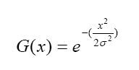
In order to simplify the computation, we adapt another equation equal to the equation , this equation is first-order derivative function of Guassian function.
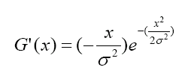
Because the computation of 2-dimension convolution is complex and large. We find the gradient by convolve x-direction and y-direction individually in fact as below:

7. Second-Order Derivative Edge Detection

The Laplacian of a 2-D function f (x, y) is a second-order derivative defined as

There are two digital approximations to the Laplacian for a 3×3 region:

where the z’s are defined in Fig 1.1 . Masks for implementing these two equations are
shown in Fig.7.1

0 | −1 | 0
−1 | 4 | −1
0 | −1 | 0
(a)
−1 | −1 | −1
−1 | 8 | −1
−1 | −1 | −1
(b)

Fig.7.1 Two kind of 3×3 Laplacian mask.
The Laplacian is usually combined with smoothing as a precursor to finding edges via zero-crossings. The 2-D Gaussian function
,
where σ is the standard deviation, blurs the image with the degree of blurring being determined by the value of σ. The Laplacian of h is
.
This function is commonly referred to as the Laplacian of Gaussian (LOG).
0 | 0 | 0 | -1 | -1 | -2 | -1 | -1 | 0 | 0 | 0
0 | 0 | -2 | -4 | -8 | -9 | -8 | -4 | -2 | 0 | 0
0 | -2 | -7 | -15 | -22 | -23 | -22 | -15 | -7 | -2 | 0
-1 | -4 | -15 | -24 | -14 | -1 | -14 | -24 | -15 | -4 | -1
-1 | -8 | -22 | -14 | 52 | 103 | 52 | -14 | -22 | -8 | -1
-2 | -9 | -23 | -1 | 103 | 178 | 103 | -1 | -23 | -9 | -2
-1 | -8 | -22 | -14 | 52 | 103 | 52 | -14 | -22 | -8 | -1
-1 | -4 | -15 | -24 | -14 | -1 | -14 | -24 | -15 | -4 | -1
0 | -2 | -7 | -15 | -22 | -23 | -22 | -15 | -7 | -2 | 0
0 | 0 | -2 | -4 | -8 | -9 | -8 | -4 | -2 | 0 | 0
0 | 0 | 0 | -1 | -1 | -2 | -1 | -1 | 0 | 0 | 0

Fig.7.2 An 11×11 mask approximation to Laplacian of Gaussian (LOG).
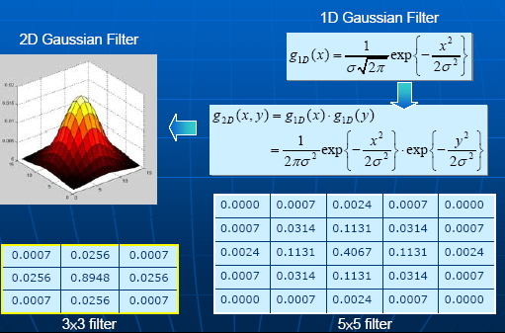
Fig.7.2 The Laplacian of Gaussian Edge Detection

Because second-order derivative operator is sensitive to noise, we use low-pass filter to eliminate the noise first. We combine Guassian filter with Lapacian operator so that we get Laplacian of Gaussian Edge Detector. We take advantage of the property of Gaussian function to distribute the noise.

8. Hilbert Transform for Edge Detection

There is another method for edge detection that uses the Hilbert transform (HLT). The HLT is
and * means convolution. Alternatively,
where G( f ) = FT [g(x)] (FT means the Fourier transform), G_{H}( f ) = FT [g_{H} (x)], and
,

where the sign function is defined as

9. Short Response Hilbert Transform for Edge Detection

Based on Canny’s criterion [5], we develop the short response Hilbert transform (SRHLT), which is the intermediate of the original HLT and the differentiation operation. For edge detection, the SRHLT can compromise the advantages of the HLT and differentiation. It can well distinguish the edges from the non-edge regions and at the same time are robust to noise. We also find that there are many ways to define the SRHLT. If the constraints which come from Canny’s criterion are satisfied, the resultant SRHLT will have good performance in edge detection.

The Definition of the SRHLT
We combine the HLT and differentiation to define the SRHLT. From the theorem of the Fourier Transform,
,
where
,
Therefore, from the scaling property of the FT:
,
we obtain
.
From, we can define the short response Hilbert transform (SRHLT) as:

In fact,
to compromise the goals of “higher distinction” and “noise immunity” and achieve the requirement of “good detection” proposed by Canny, the impulse response of the edge detection filter should satisfy:

(Constraint 1) The impulse response h(x) is neither too short nor too long. If we define
,
then T should satisfy
A₁ < T < A₂,
where A₁ and A₂ are some thresholds. To achieve higher immunity to noise, T should be larger than a certain threshold A₁. To make the filter have higher ability for distinguishing the edge from the non-edge region, T should be smaller than a certain threshold A₂.

(Constraint 2)
where x₀ = 0 or x₀ is very close to 0.

(Constraint 3) if |x₂| > |x₁| ≥ |x₀|,
or although in some conditions the impulse response is not strictly descending but the local peak is much smaller than the global peak |h(x₀)|.

(Constraint 4) h(x) = −h(−x).

In fact, there are many alternative ways to define the SRHLT. There are also other functions that satisfy Canny’s criterions and can be treated as the impulse responses of SRHLTs. For example,

when b=1

when b=0

where

where b sinc(x) = sin(π x)/(π x),

Experiment

Here, we show the experiments of these algorithms as below.(first-order derivative edge detection, second-order derivative edge detection, Hilbert Transform for edge detection, Short Response Hilbert Transform for edge detection and Improved Harri’s Algorithm for corner and edge detection) We can found that different detectors have different effect on the images. Some detectors can detect few zero-crossings while others can detect many zero-crossings. The condition depends on which detector we choose and which threshold values we set. The experiment result is simulated by matlab as shown on the Figures as below:

First-order derivative edge detection:

(a) Original image. (b) Roberts operator.
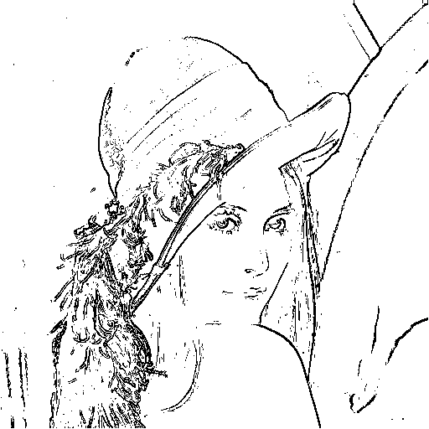

(c) Prewitt operator. (d) Sobel operator.

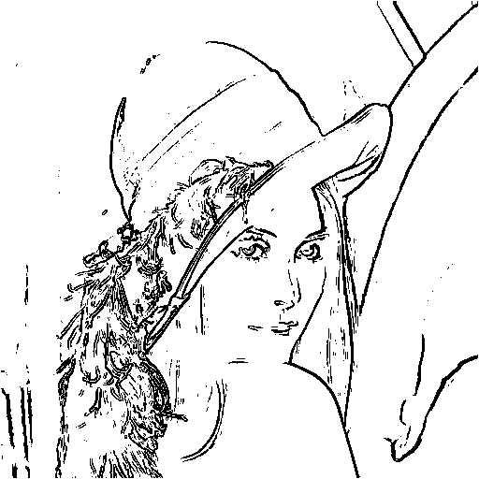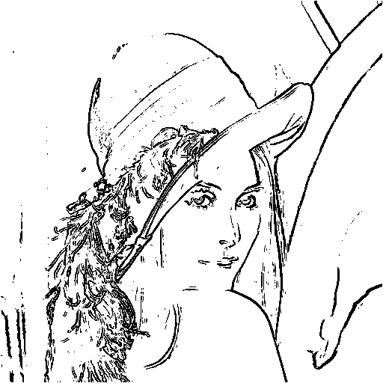

Fig.10.1 Examples of edge detection using three different operators.

Second-order derivative edge detection:

(a) Original image. (b) Laplacian mask of Fig.(a)
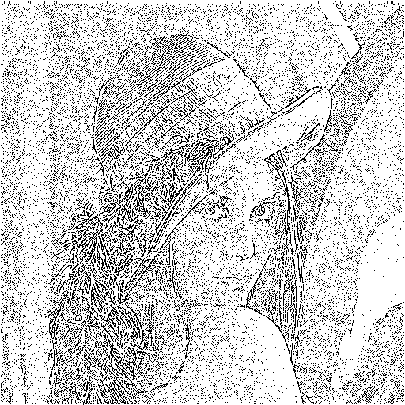
(c) Laplacian mask of Fig.(b) (d) LOG mask of Fig.(b)

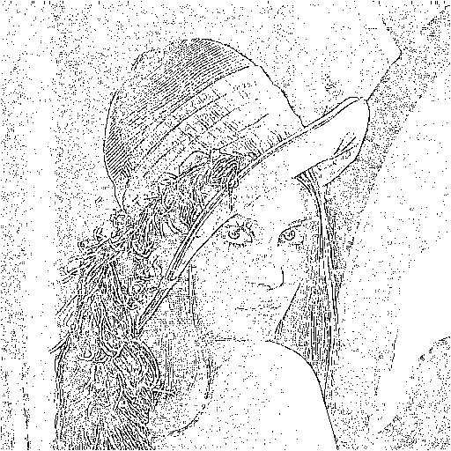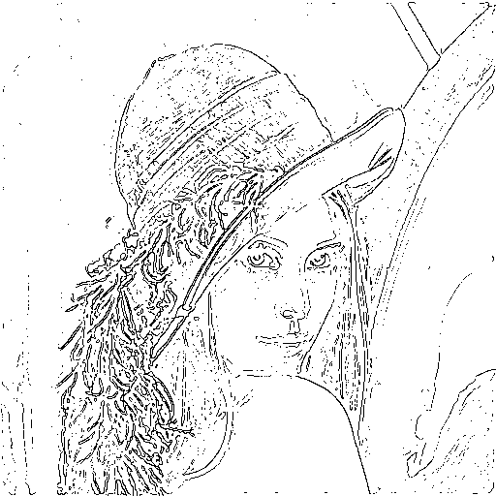
Fig.10.2 Examples of edge detection using three different Laplacian masks.
Hilbert Transform for Edge Detection:

Fig.10.3 Using HLTs to detect (a) the sharp edges, (c) the step edges with noise, and (e) the ramp edges. (b)(d)(e) are the results of the HLTs of (a)(c)(e).

Short Response Hilbert Transform for Edge Detection:
Fig.10.4 Using SRHLTs to detect the sharp edges, the step edges with noise, and the ramp edges. Here we choose b = 1, 4, 12, and 30.
(a) Original image (b) Results of differentiation
(c) Results of the HLT (d) Results of the SRHLT, b=8
Fig.10.5 Experiments that use differentiation, the HLT, and the SRHLT (b=8) to do edge detection for Lena image.

(a) Lena + noise, SNR = 32 (b) Results of differentiation
(c) Results of the HLT (d) Results of the SRHLT, b=8
Fig.10.6 Experiments that use differentiation, the HLT, and the SRHLT (b=8) to detect the edges of Lena image interfered by noise.

(a) b = 0.5 for Lena image (b) b = 0.5 for Lena + noise
(c) b = 20 for Lena image (d) b = 20 for Lena + noise
(e) b = 8 for Lena image (f) b = 8 for Lena + noise
Fig.10.7 Using the SRHLT to detect the edges of Lena image or Lena + noise when b is chosen as 0.5 ,8 and 20.

Matlab simulation(SRHLT)
b=0.1 b=5
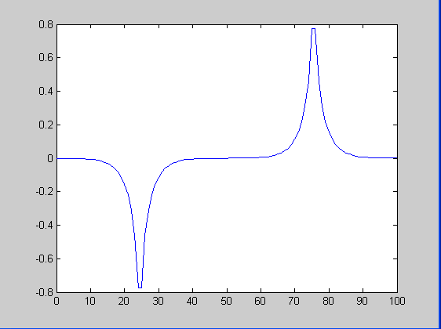
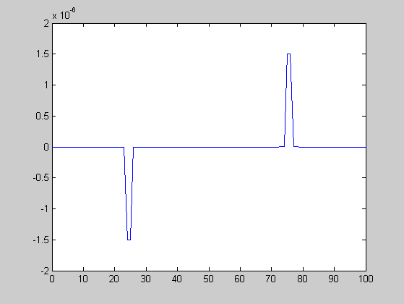

b=12 b=50
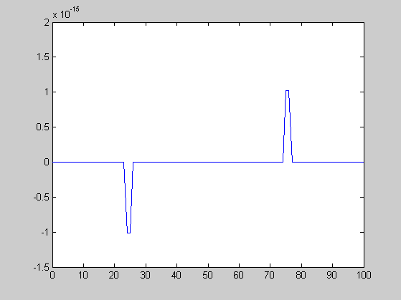
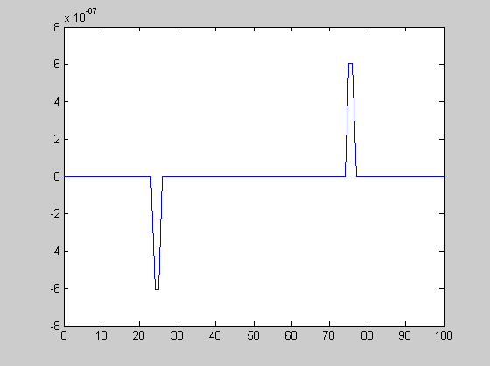

Fig.10.8 Using SRHLTs to detect the sharp edges. Here we choose b = 1, 4, 12, and 30.

Conclusions

In the research, we have many methods to make edge detections, such as first-order derivative edge detection, second-order derivative edge detection, HLT and SRHLT. We can view SRHLT as the medium between the differentiation operation and the Hilbert transform (HLT) for edge detection. SRHLT has higher robustness for noise than HLT and can successfully detect ramp edges. The SRHLT can also avoid the pixels that near to an edge be recognized as an edge pixel, which is usually an important problem when using the HLT for edge detection. We also do several experiments and show that the SRHLT can successfully detect the edges of a complicated image. Moreover, directional edge detection (i.e., detect the edges with certain direction) are also the possible applications of the SRHLT. Fortunately, we can use improved Harris’ algorithm to improve the drawbacks of SRHLT. The change is that we observe the sign of variation. It can avoid misjudging the pixel at the wrong location and is also helpful for increasing the robustness.
Refernces

[1] Soo-Chang Pei, Jian-Jiun Ding, ” Imporved Harris’ Algotithm For Coner And
Edge Detections”, vol 1, 2005.

[2] William K. Pratt , “Digital Image Processing_William K. Pratt 3rd ”, chapter 15.

[3] Jiun-De Huang, “Image Compression by Segmentation and Boundary
Description”, chapter 2.

[4] D. Ziou & S. Tabbone, “Edge Detection Techniques An Overview”, 1998.

[5] J. Canny, “A Computational Approach to Edge Detection,” IEEE Trans. Pattern
Analysis and Machine Intelligence, PAMI-8, 6, November 1986, 679–698.

[6] Maar, D., Hildreth E., “Theory of edge detection”, Proceedings Royal Soc. London, vol. 207, 187-217, 1980

[7] Advanced Edge Detection Technique: Techniques in Cimputational Vision:
http://www.cpsc.ucalgary.ca/Research/vision/501/edgedetect.pdf

